Case 6-Afr-Mali-Djenné-Bozo or Sorko Culture-Terra cotta-1350 CE

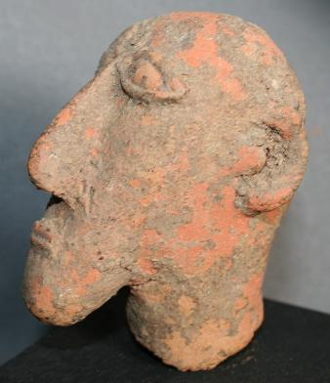 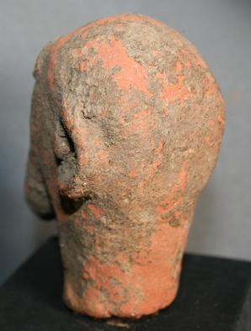

Figs. 1-2. Mali-Djenné Djeno-Bozo-Sorko Culture-14th c CE

Case no.: 6

Accession Number:

Formal Label: Mali-Djenné Djeno-Bozo People-Sorko Culture-14th c

**Display Description:** The Sorko Culture numbers ca 40,000 semi-nomadic Mande speakers of the northern group of the Bozo People who depend on fishing on the Middle Niger and Bani Rivers in the Republic of Mali. In the 14th c CE, when Arab traders were traveling caravan routes across the Sahara Desert to the trading areas of West Africa along the Niger River, the Bozo people used locally available clay to produce unusual terracotta clay busts of famous trans-Saharan Arab traders of which Atlantika has two. This very rare terracotta head of a male with Semitic features dates to this period. This terracotta was purchased in the 1960’s in the modern town of Djenné-Djeno (Jenne-Jeno), 3 km (1.9 mi) s of the archaeological site, which was occupied from 250 BCE to 900 CE, when the modern city was built concurrently with the Great Mosque of Djenné (that was rebuilt in 1907). This individual, who was of high rank, may have been one of the leaders who was responsible for the building of the original Mosque.

**LC Classification:** DT551.42

Date or Time Horizon: 19th c

Geographical Area: site of Djenné-Djeno, Mali, on the flood plain of the Bani River,3 km (1.9 mi) s of modern town.

**Map:**

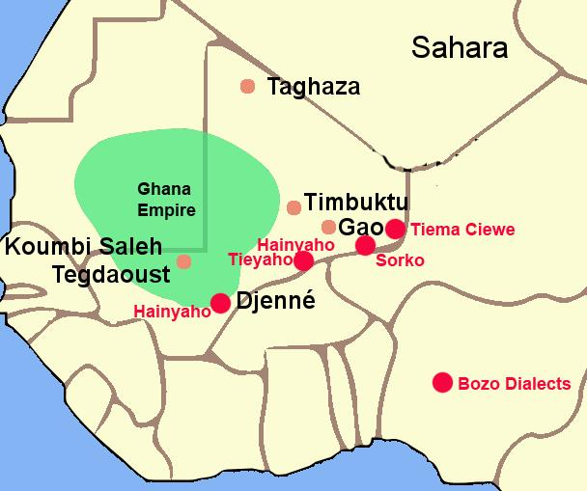

Fig. 3. The Ghana Empire 1000-1400 CE showing the ethnolinguistic groups along the Niger River. After <https://i.pinimg.com/564x/c6/a7/9b/c6a79b7443105f363ff965ebf420b7fd.jpg>

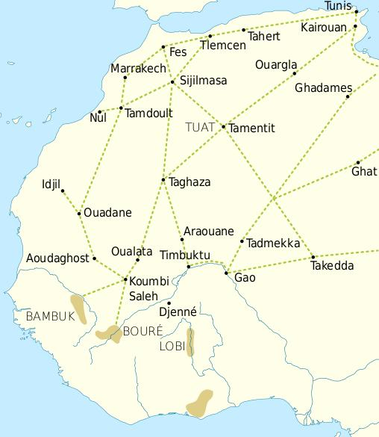

Fig. 4. Trade routes of the Western Sahara c. 1000-1500. Goldfields are indicated by light brown shading. After https://i.pinimg.com/564x/69/15/ce/6915ce6f4fd34025787fe59bd44f9eae.jpg

This trade resulted in an increasing surplus that helped expand urban centers such as Gao, Timbuktu and Djenné. In this context the Bozo founded the cities of Djenné and Mopti, where they built magnificent mosques of mud brick. 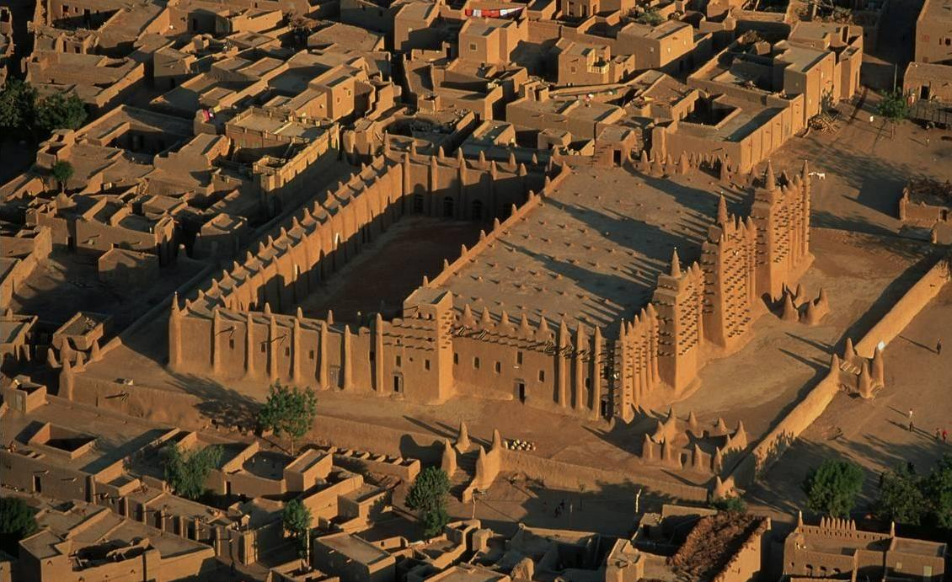

Fig. 5. The Great Mosque of Djenné, Mali, after https://i.pinimg.com/564x/14/37/f7/1437f73d8b6a49de0f14c389f9964326--africa-art-mali.jpg.

**GPS coordinates:** Djenné-Djeno, Mali: [13°53′26″N 4°32′25″W](https://tools.wmflabs.org/geohack/geohack.php?pagename=Djenné-Djenno&params=13_53_26_N_4_32_25_W_region:ML_type:landmark_source:dewiki)

Cultural Affiliation:

Medium: terracotta

Dimensions:

Weight:

Condition: original

Provenance:

**Discussion:**

The Sorko (or Bozo), a West African ethnic group, are considered "the masters of the river" and **are** the principal fishing people of the Inner Niger Delta in Mali. The name *Bozo* is thought to derive from the neighboring Bambara people's word "*bo-so*," meaning "bamboo" or "grass house" which has been accepted as referring to the whole of the ethnic group. However, local people refer to themselves by one of four dialects: Hainyaho (a few thousand speakers), Tièma cièwe (2,500 speakers in 1991), Tiéyaho (a few thousand speakers) and Sorko or Sorogama (200,000 speakers in 2005) all of which form a branch of northwestern Mande languages.

The Sorko culture took shape under the Ghana Empire in what is now southeastern Mauritania and western Mali that was founded before 830 CE, when the Bozo took possession of the banks of the Niger. This event was of great importance since the domesticated camel provided transport for trans-Saharan trade in gold, ivory, salt and natron which could then be exchanged for manufactured goods to Mediterranean ports connecting to Europe, to Egypt and to the Middle East.

The Sorko are also famous for their metal smithing and have developed their art to a high degree by using riverine themes such as the two bronze examples shown here, one of a **mermaid** that may have its inspiration from the first Europeans who entered their area in the early sixteenth century and the other of a **dual wedding party being escorted along the Niger River in a crocodile-prow fishing pirogue**.

**References:**

Gaillais, Jean. 1978-80. *La delta intérieur du Niger*. Mémoires de l'Institut Fondamental de l'Afrique Noire 79. Amsterdam: Swets & Zeitlinger, 1978-80.

Grunne, Bernard de. 1982. *La statuaire en terre cuite du delta intérieur du Niger au Mali = Figürliche Terrakotten aus dem Gebiet des Niger-Binnendeltas in Mali = The terracotta statuary of the inland delta of the Niger in Mali.* München: Galerie Biedermann

Ligers, Z. 1964-1969. *Les Sorko (Bozo): Maîtres du Niger: Étude ethnographique*. Volumes 1-4. Paris: Librairie des Cinq Continents.

**Appendix:**

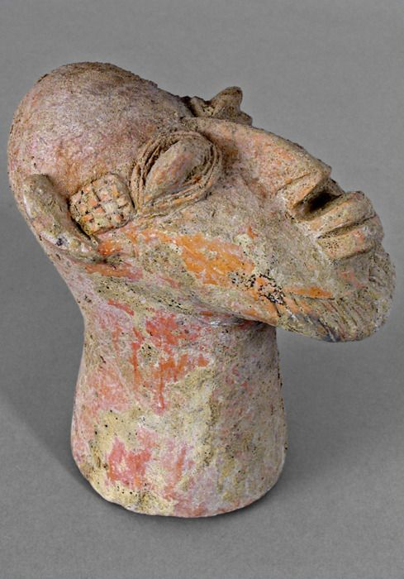

Fig. 6. Djenné-Djeno terracotta head of a 14th c Semitic trader, Yale University, Art Museum, Acc. No. 0128792.